Guided Practice - Build-A-Page Workshop Lab Report
Use this template to document your work as you complete your assignment.

Your Information
Your Name: Daryl Hymel - darhym6254
Assignment Title: 1.5 Guided Practice - Build-A-Page Workshop
GitHub Repository: https://github.com/darhym6254/1.5-Guided-Practice

Development Summary
Briefly describe what you added to the starter HTML file and how it changed the content of the page.
I added semantic HTML5 elements to organize the page, including a header, navigation menu, main content area, and a footer. I also added a comparison table, customization list, design form, build date, and navigation links.
These changes turned the starter file into a complete, more of a webpage. The content is now organized, and accessible for screen readers.

Semantic HTML Elements Used
Complete the table by identifying five semantic elements you used and explaining their purpose on the page.
Semantic Element | Where You Used It | Purpose / Accessibility Benefit
<header> | At the top of the <body>, wrapping the <h1> "Build-A-Page Workshop" title and the tagline paragraph. | Identifies the introductory content of the page. Assistive technology exposes it as the "banner" landmark, so a screen-reader user can jump straight to it and hear what the page is.
<nav> | Directly below the header, wrapping the <ul> of links to #home, #table, and #form. | Marks the block as the primary navigation landmark. Screen readers can announce it as a navigation region and let the user list or skip the links as a group instead of reading them as loose text.
<main> | Wrapping the primary content region of the page (id="home", the target of the "Main" nav link). | Identifies the one region holding this page's unique content. It powers "skip to main content," letting keyboard and screen-reader users bypass the repeated header and nav.
<section> | Used three times: the Feature Comparison table, the Customization Options list, and the Design Preferences form, each with its own <h2>. | Groups related content under a heading, which builds a real document outline. A screen-reader user can navigate the page heading by heading rather than reading top to bottom.
<footer> | At the very bottom of the page content, just before the closing </main> tag, holding the copyright line and the "Created by" credit. | Marks closing and supporting information as the "contentinfo" landmark, so it is announced as the page footer instead of being mistaken for more main content.

Code Evidence
Insert screenshots that show the completed code for this assignment. Make sure your screenshots are legible and contain the computer system date and time.

Screenshot 1: Completed HTML code in Visual Studio Code
Paste your screenshot below this line:
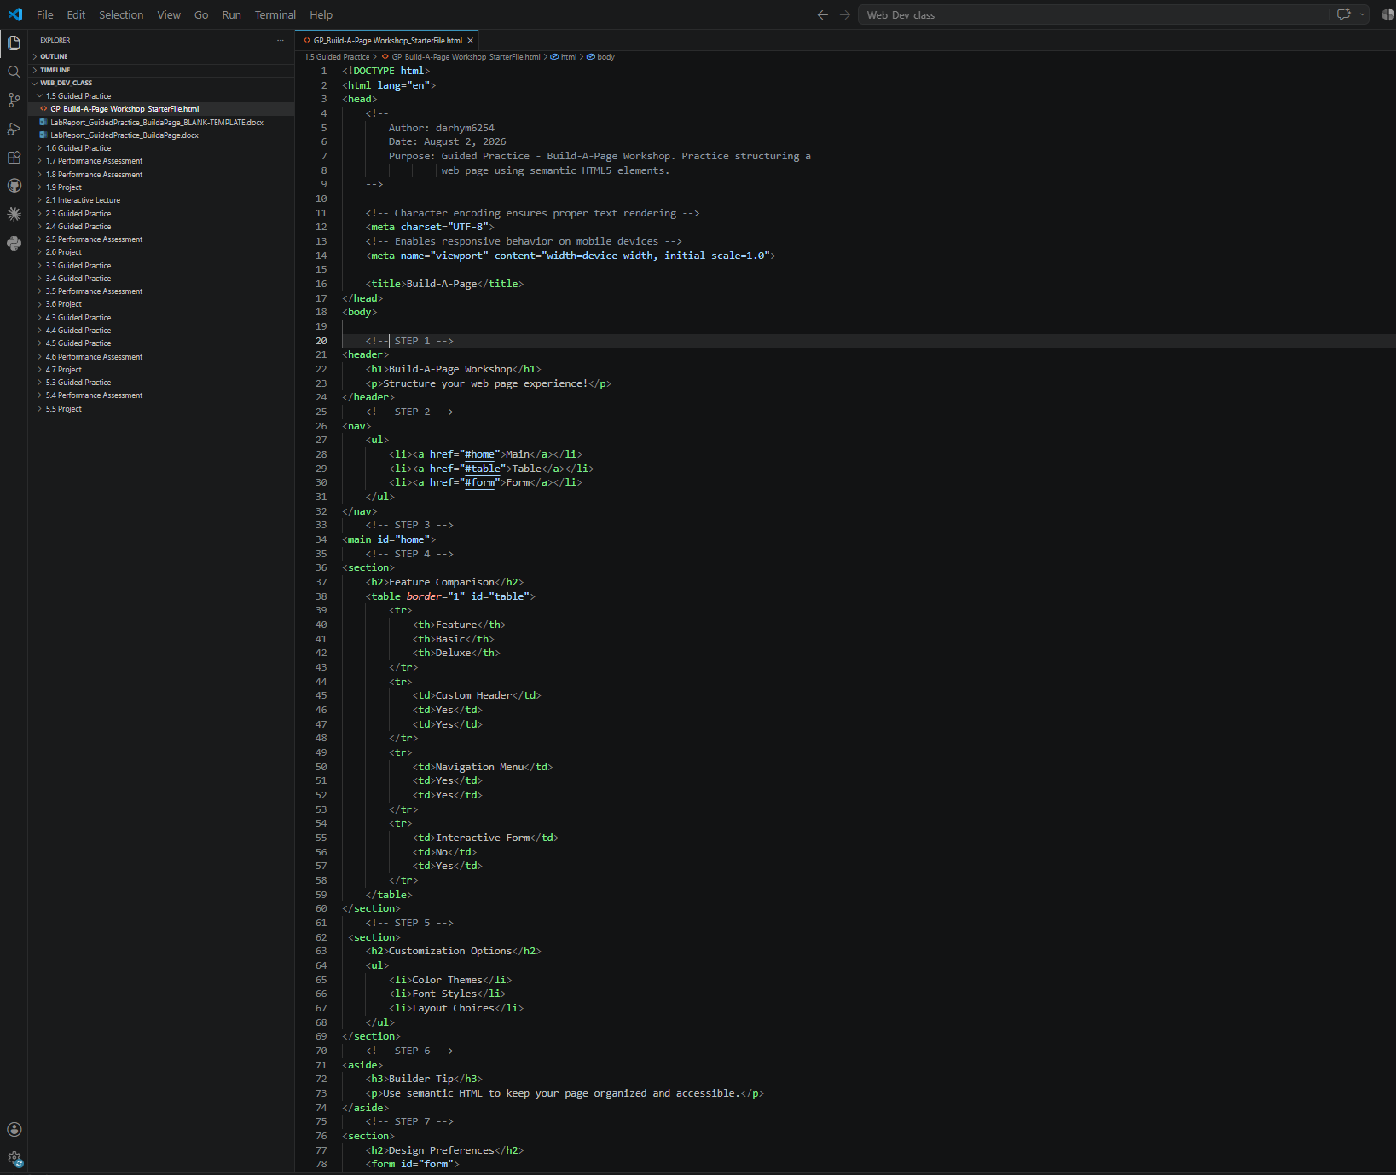

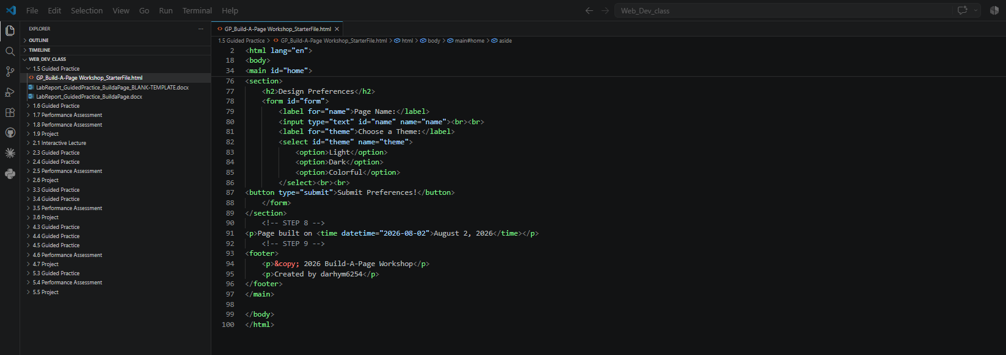

Screenshot 2: Rendered web page in a browser
Paste your screenshot below this line:
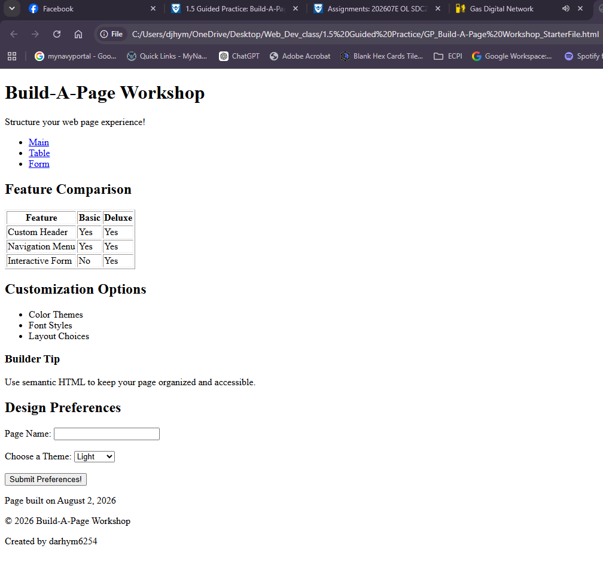

Reflection
In 2-3 sentences, explain how semantic HTML helps organize a web page or improve accessibility.
Semantic HTML gives every part of a page a name instead of leaving it as a generic <div>, so the structure of the document is visible in the markup itself and far easier to read, style, and maintain. Assistive technologies turn those elements into landmarks and a heading outline, which lets a screen-reader user jump directly to the navigation, the main content, or a specific section rather than listening through the entire page. Browsers and search engines rely on the same cues to work out which content matters most, so choosing the right element improves organization and accessibility at the same time.

